Test

Now when I start the rainbow line flashes on, I thought the first time it came on slowly…might be wrong.

Loved Bleak House – is it the whole book?

Eke out worked ok.

I can’t tell you how long I played Ballout before I realized that I wasn’t a highl;y skilled player ….oh yes I can…

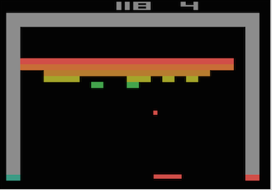

…and even longer to find out that the keys were controlling the ‘ball’ and after all that I / we didn’t get to remove all the bricks before the game ended.

Pongout froze on me a couple of times, all I could do was leave the browser. Last time it only worked for one hit, is that the idea? Feels like it is stuck.

Blackout: score 9 oh, oh.

Blinkout is cool, like the way it attacks both sides. Took me a while to get used to it.

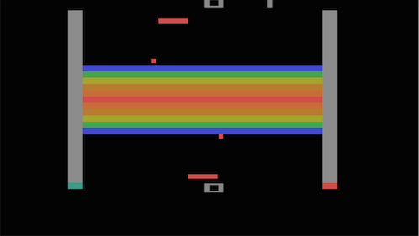

As far as it went after one hit. On another time it did one hit and reverted to the menu.